1.

#include<iostream>

#include<cmath>

using namespace std;

class Circle{

private:

double radius;

public:

circle(double r):radius(){}

double calculateArea(){

return M_PI*radius*radius;

}

double calculatecircumference(){

return 2*M_PI radius;

}

};

int main(){

double radius;

cout<<"enter the radius of the circle:";

cin>>radius;

Circle myCircle(radius);

cout<<"area of the circle:"<<myCircle.calculaeArea()<<endl;

cout<<"Circumference of the circle:"<<myCircle.calculateCircumference()<<endl;

return 0;

}

2.

#include<iostream>

#include<string>

using namespace std;

class Student{

public:

Student():name("Unknown"){}

Student(const string&StudentName):name(StudentName){

}

void printName(){

cout<<"Student Name:"<<name<<endl;

}

private:

string name;

};

int main(){

Student student1;

student1.printName();

Student student2("Anusha");

student2.printName();

return 0;

}

Output:

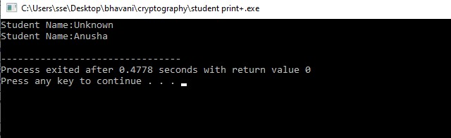

3. #include<iostream>

using namespace std;

int main(){

int rows;

cout<<"enter a rows:";

cin>>rows;

for(int i=1;i<=rows;i++){

for(int j=1;j<=i;j++){

cout<<"1";

}

cout<<"\n";

}

return 0;

}

Output:

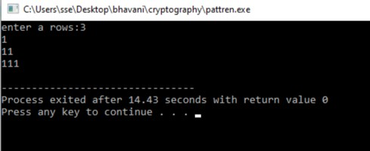

4. #include<iostream>

#include<string>

using namespace std;

class Item{

protected:

title(string);

authorname(string);

int year;

public:

Item(const string&_title,const string&_authorname,int_year):title(_title),authorname(_authorname),year(_year){}

void display(){

cout<<"Title:"<<title<<endl;

cout<<"AuthorName"<<authorname<<endl;

cout<<"year"<<year<<endl;

}

};

class Book:public Item{

private:

int numberofpages;

public:

Book(const string&_title,const string&_authorname,int_year,int_numberofpages):Item(_title,_authorname),numberofpages(_numberofpages)[]

void display(){

Item::display();

cout<<"Number of Pages"<<numberofpages<<endl;

}

};

nt main(){

Book myBook("Sample book","John doe",2020,300);

cout<<"Book Details:\n";

myBook.display();

return 0 ;

}